

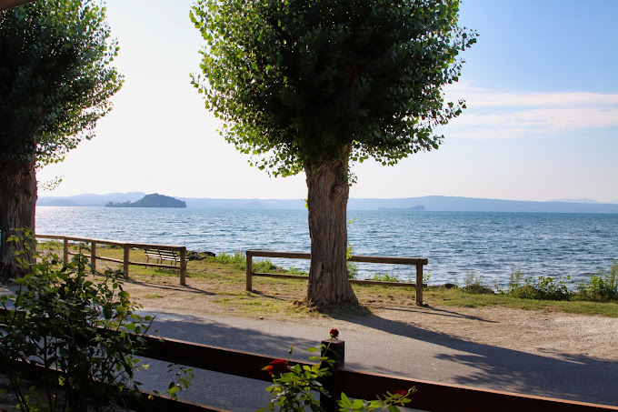

**Maestri del Lavoro**

*Consolato di Viterbo*

6 maggio 2023

MENU

**ANTIPASTI**

*Cannolicchi gratinati-cozze al pomodoro-insalata di mare*

**PRIMI**

*Gnocchetti agli scampi*

*Risotto alla pescatora*

**SECONDI e CONTORNI**

*Grigliata di scampi e gamberoni*

*Frittura mista*

*Con patate*

**DOLCE**

*Torta personalizzata*

**SPUMANTE**

*Acqua/vino/ Bevande*

**CAFFE’ - AMARO**

[**Indirizzo**](https://www.google.com/search?sxsrf=APwXEdfheaQQQM9l3e3kOc_Cx7qApmzJUw:1681456809141&q=ristorante+isola+blu+indirizzo&ludocid=295859177707000546&sa=X&ved=2ahUKEwiFjcHe6qj-AhWa7rsIHYoEAfsQ6BN6BAh3EAI)**:**Via del Lago, 122, 01027 Montefiascone VT [**Telefono**](https://www.google.com/search?sxsrf=APwXEdfheaQQQM9l3e3kOc_Cx7qApmzJUw:1681456809141&q=ristorante+isola+blu+telefono&ludocid=295859177707000546&sa=X&ved=2ahUKEwiFjcHe6qj-AhWa7rsIHYoEAfsQ6BN6BAhpEAI)**:**[0761 828312](https://www.google.com/search?q=isola+blu&sxsrf=APwXEdfeipIkLn-sZX5xTDctotgYAVNqvA%3A1681456789937&source=hp&ei=lf44ZJG0NeT97_UP_I6dsA8&iflsig=AOEireoAAAAAZDkMpdcm3WeBtDVgq8O3pwUGizaziBxA&gs_ssp=eJzj4tFP1zc0NE4pLzI0tDBgtFIxqDA0NrI0SjSwMEo1SExKTjK0MqgwMUwyTDRNTDZLNk4xSjXy4swszs9JVEjKKQUAFpYR1A&oq=isola+blu&gs_lcp=&sclient=gws-wiz)